Current Operable Unit 3 (Brightwaters Yard) Phase III Remedial Progress for Week Ending 8/20/10
Creamer Environmental Inc., National Grid’s Remediation Contractor, has started and will continuing to mobilize to the site adjacent to where the LIRR tracks were relocated. The mobilization includes bringing construction equipment, materials, and temporary facilities to the site.
GEI, National Grid’s Remediation Oversight Consultant, continues to perform CAMP (Community Air Monitoring Program). CAMP monitoring will continue throughout the project.

Two-Week Outlook
Creamer Environmental Inc. is expected to complete mobilization of equipment, materials, and temporary facilities including mobilization and set-up by early part of the week. Excavation and load out of impacted soil is anticipated to commence week starting August 23rd 2010.
General hours of operation will continue to be Monday through Friday, 7:00 AM to 3:30 PM. However, work hours will be extended when necessary to maintain schedule or to complete critical tasks.

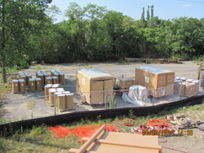
Mobilizing Odor Suppressing Foam
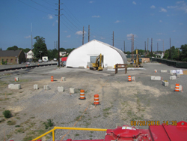
Site layout

